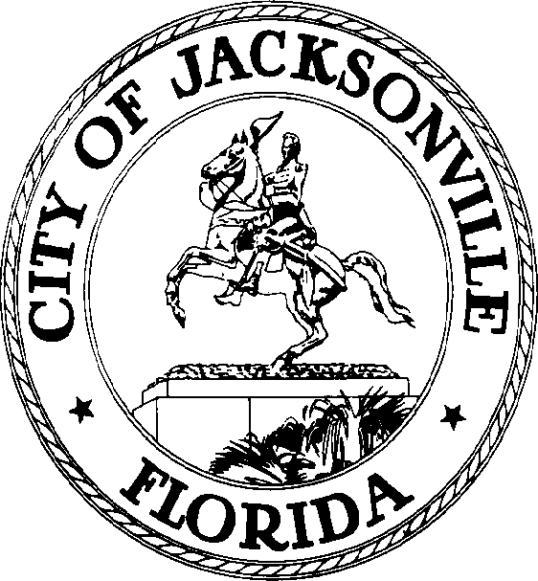

SAM C. NEWBY  Council President Group 5, At-Large  E-Mail: snewby@coj.net | OFFICE OF THE CITY COUNCIL | 117 West Duval Street City Hall, Suite 425  Jacksonville, Florida 32202  Office (904) 255-5219  Fax (904) 255-5230

February 24, 2022
Noticed Meeting
1:30 p.m.

Council President Samuel Newby will meet with Council Member Ron Salem regarding Council Leadership.

Notice is hereby given that Council President Samuel Newby will meet with Council Member Ron Salem in the Lynwood Roberts Room, City Hall 117 W. Duval St. on Tuesday, March 1, 2022, at 1:00 p.m. The purpose of this meeting is to discuss Council Leadership.

Due to COVID-19, masks are recommended, and social distancing will be in place.

Pursuant to the American with Disabilities Act, accommodations for persons with disabilities are available upon request. Please allow 1-2 business days notification to process; last-minute requests will be accepted but may not be possible to fulfill. Please contact Disabled Services Division at: V 904-255-5466, TTY-904-255-5476, or email your request to KaraT@coj.net.

cc: Council Members/Staff
Jessica Matthews, Chief of Legislative Services
Jeff Clements, Chief of Research
Yvonne Mitchell, Chief of Administrative Services
CITYC@COJ.NET
Electronic Notice Kiosk – 1st Floor City Hall
Public Notice System – City Council Web Page
Media Box
File Copy

